Chapter 7, Problem 66.

Using Fig. 7.131, design a problem to help other students better understand first-order op amp circuits.
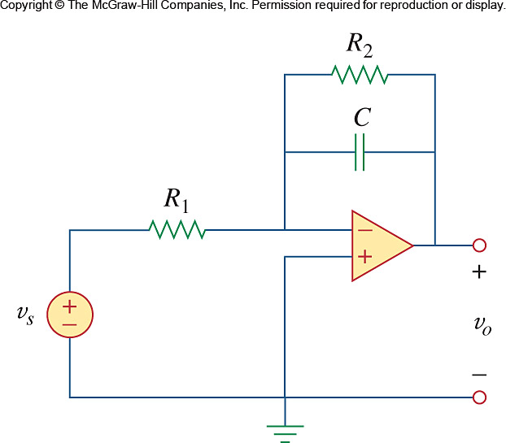

Figure 7.131
For Prob. 7.66.

